**INFORMATION SECURITY - ASSIGNMENT - 1**

**Munir Abbasi - K20-0244 - BSE-7B**

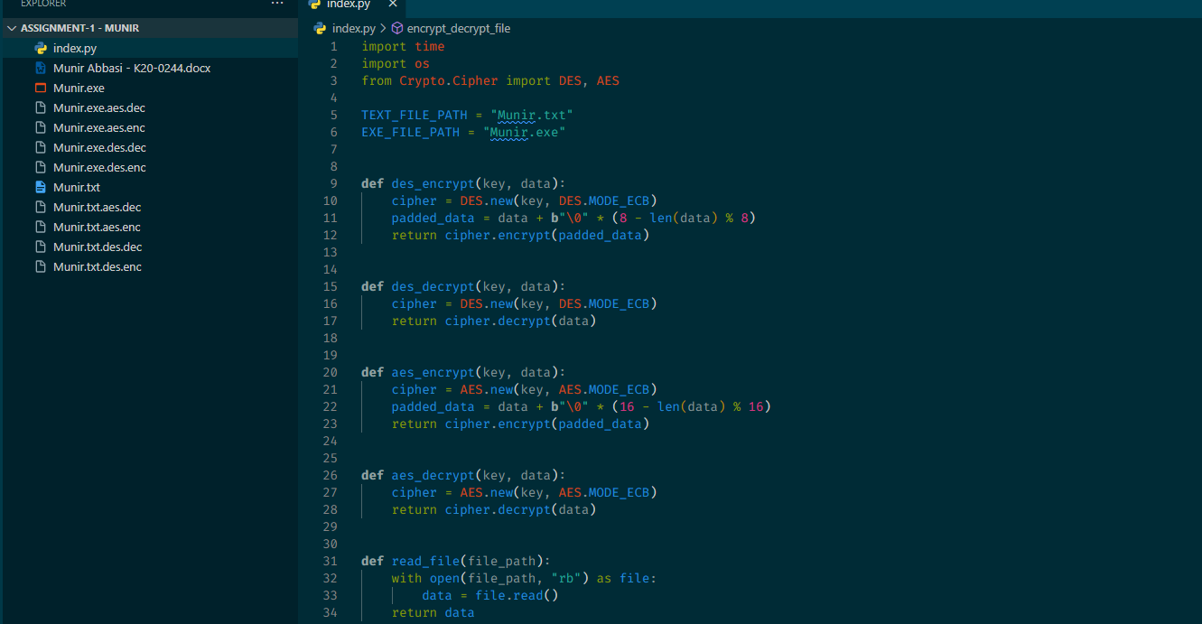

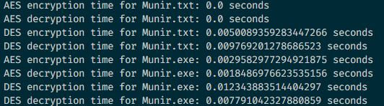

import time

import os

from Crypto.Cipher import DES, AES

TEXT_FILE_PATH = "Munir.txt"

EXE_FILE_PATH = "Munir.exe"

**def** des_encrypt(key, data):

    cipher = DES.new(key, DES.MODE_ECB)

    padded_data = data + **b**"\0" * (8 - len(data) % 8)

    return cipher.encrypt(padded_data)

**def** des_decrypt(key, data):

    cipher = DES.new(key, DES.MODE_ECB)

    return cipher.decrypt(data)

**def** aes_encrypt(key, data):

    cipher = AES.new(key, AES.MODE_ECB)

    padded_data = data + **b**"\0" * (16 - len(data) % 16)

    return cipher.encrypt(padded_data)

**def** aes_decrypt(key, data):

    cipher = AES.new(key, AES.MODE_ECB)

    return cipher.decrypt(data)

**def** read_file(file_path):

    with open(file_path, "rb") as file:

        data = file.read()

    return data

**def** write_file(file_path, data):

    with open(file_path, "wb") as file:

        file.write(data)

**def** encrypt_decrypt_file(file_path, algorithm, key):

    data = read_file(file_path)

    if algorithm == "DES":

        start_time = time.time()

        encrypted_data = des_encrypt(key, data)

        end_time = time.time()

        print(

**f**"DES encryption time for {file_path}: {end_time - start_time} seconds")

    elif algorithm == "AES":

        start_time = time.time()

        encrypted_data = aes_encrypt(key, data)

        end_time = time.time()

        print(

**f**"AES encryption time for {file_path}: {end_time - start_time} seconds")

    else:

        raise ValueError("Invalid algorithm")

    write_file(file_path + "." + algorithm.lower() + ".enc", encrypted_data)

    encrypted_data = read_file(file_path + "." + algorithm.lower() + ".enc")

    if algorithm == "DES":

        start_time = time.time()

        decrypted_data = des_decrypt(key, encrypted_data)

        end_time = time.time()

        print(

**f**"DES decryption time for {file_path}: {end_time - start_time} seconds")

    elif algorithm == "AES":

        start_time = time.time()

        decrypted_data = aes_decrypt(key, encrypted_data)

        end_time = time.time()

        print(

**f**"AES decryption time for {file_path}: {end_time - start_time} seconds")

    else:

        raise ValueError("Invalid algorithm")

    write_file(file_path + "." + algorithm.lower() + ".dec", decrypted_data)

**def** main():

    aes_key = **b**"1234567890123456"

    des_key = **b**"abcdefgh"

    for i in range(2):

        if os.path.getsize(TEXT_FILE_PATH) < 10000000:

            if i == 0:

                algorithm = "AES"

                key = aes_key

            else:

                algorithm = "DES"

                key = des_key

            encrypt_decrypt_file(TEXT_FILE_PATH, algorithm, key)

        else:

            print("File size is greater than 10MB")

    for i in range(2):

        if os.path.getsize(EXE_FILE_PATH) < 10000000:

            if i == 0:

                algorithm = "AES"

                key = aes_key

            else:

                algorithm = "DES"

                key = des_key

            encrypt_decrypt_file(EXE_FILE_PATH, algorithm, key)

        else:

            print("File size is greater than 10MB")

if __name__ == "__main__":

    main()